Software Requirements Specification

for

Flip Shop

Marketplace for Buying and Selling Digital Assets

**Version 1.0 approved**

**Areej Razzaq**

**Huda Fatima**

**SEECS, NUST**

**12/12/2022**

**Table of Contents**

**Table of Contents ii**

**Revision History ii**

**1. Introduction 1**

1.1 Purpose 1

1.2 Document Conventions 1

1.3 Intended Audience and Reading Suggestions 1

1.4 Product Scope 1

1.5 References 1

**2. Overall Description 2**

2.1 Product Perspective 2

2.2 Product Functions 2

2.3 User Classes and Characteristics 2

2.4 Operating Environment 2

2.5 Design and Implementation Constraints 2

2.6 User Documentation 2

2.7 Assumptions and Dependencies 3

**3. External Interface Requirements 3**

3.1 User Interfaces 3

3.2 Hardware Interfaces 3

3.3 Software Interfaces 3

3.4 Communications Interfaces 3

**4. System Features 4**

4.1 System Feature 1 4

4.2 System Feature 2 (and so on) 4

**5. Other Nonfunctional Requirements 12**

5.1 Performance Requirements 12

5.2 Safety Requirements 13

5.3 Security Requirements 13

5.4 Software Quality Attributes 13

5.5 Business Rules 14

**6. Other Requirements 14**

**Appendix A: Glossary 15**

**Appendix B: Analysis Models 16**

**Appendix C: To Be Determined List 2622**

**Revision History**

|  |  |  |  |
| --- | --- | --- | --- |
| **Name** | **Date** | **Reason For Changes** | **Version** |
|  |  |  |  |
|  |  |  |  |

# Introduction

## Purpose

Flip Shop presents a solution for the buying and selling of digital assets. It aims to act as a third party between buyer and seller. Flip Shop will provide a marketplace where people can buy and sell online business, such as Daraz Seller Accounts and Blogs. Flip Shop will act as broker between both buyer and seller. It will ensure the smooth transaction of business between both parties. With Flip Shop, we aim to automate the evaluation process by using the analytics provided for the business by the sellers. Additionally, transparency will be ensured by Flip Shop. This document records the agreed requirements for Flip Shop. The document describes the system features on a higher level without going into minute details.

## Document Conventions

TBD

## Intended Audience and Reading Suggestions

The document presents the intended features of the Flip Shop. Each feature is further described with different levels of detail. This document is best suited for developers, stakeholders, users, quality assurance teams and documentation writers. The document should be read from top to bottom. The document follows the structure of first describing the system on an abstract level. It is then followed by an explanation of system features. Consequently, system features are modeled using use case diagrams to give the readers of the document a visual representation of the system.

## Product Scope

Flip Shop aims to solve the needs of buyer and seller where they can relay on a trusted source for their assets. Flip Shop will help the sellers by providing a dynamic marketplace where they can advertise for their assets and earn money. On the other hand, Flip Shop will fulfill the needs of buyers by providing them with an authenticated and reliable marketplace. Additionally, with each transaction Flip Shop can earn money, resulting in a profitable business in long run.

## References

None

# Overall Description

## Product Perspective

Flip Shop is a novel project with one of its kind in the local community. Several other international options exist for buying and selling of digital assets. However, these solutions fail to satisfy the needs of the local community. Therefore, Flip Shop aims to develop a solution where local community can flip their digital assets. Hence, catering for the needs of both buyers and sellers.

## Product Functions

Flip Shop aims to develop features for both sellers and buyers ensuring a smooth and transparent transaction between the two. Sellers will list the business on Flip Shop from where it will be available to the potential buyers. Sellers will be filling all the required details for the asset. All the listings made by different sellers will be visible to buyers. The buyer can view listings and show their interest in a particular listing. Flip Shop will also provide its prospective clients a smooth chat medium to turn warm interests in actual transactions. Different filters and analytics will be provided to Flip Shop users to ensure transparency throughout the entire journey of the user, thus enabling a smooth and reliable experience.

## User Classes and Characteristics

Flip Shop targets the following two classes of users.

* Sellers

The users of Flip Shop who can list their digital asset on the website to secure potential deals.

* Buyer

The users of Flip Shop who can show interest in a particular list and make a successful transaction using the website.

* Admin

Admin has all the privileges to block any user. Additionally, the admin can overview the overall performance of the transactions.

## Operating Environment

The website shall be compatible with the following browsers:

* Chrome
* Firefox
* Safari
* Internet Explorer > 7.0
* Edge

The website shall also be able to run smoothly on the mobile versions of the above-mentioned browsers.

## Design and Implementation Constraints

Flip Shop uses two different digital assets (Daraz Seller Accounts and Blogs) for flipping. These assets comprise of their own independent policies and restrictions. Since Flip Shop will be working with these assets type, following their policies is a must requirement for the system, hence presenting corporate and regularity constraints. The system aims to ensure transparency to its consumers by providing in-built chat support. The chat support follows communication protocols, hence posing limitation on the development process.

## User Documentation

TB (As the user interface is extremely easy to understand, user documentation is deemed not necessary, but it shall be prepared, if need be, based on the feedback of users.)

## Assumptions and Dependencies

The intended website Flip Shop will use different Application Programming Interfaces (APIs) to fetch data. These APIs include but are not limited to Google OAuth, Google Analytics, Daraz API. Due to the dependence of website on external interface, it poses limitations on usage and protocols considerations.

# External Interface Requirements

## User Interfaces

The system aims to develop independent interfaces for buyer, seller and admin. The logged user will be directed to its interface depending on the role. All of the users perform independent operations; hence they have separate interfaces expect the authentication interface which does not require any role based appearance. Additionally, the front-end interface will be implemented on React which is based on Google’s Material Designs. Therefore, the application will follow the design principles. For instance: the primary, secondary and danger sections will be consistent throughout the entire system.

## Hardware Interfaces

None

## Software Interfaces

Flip Shop is divided into three tiers dividing the responsibilities with tiers. The presentation tier will be developed in React while backend is to be developed via Laravel. The database is managed and implemented in MySQL workbench. Communication between these tiers is done by following protocols. The presentation and logical tiers are connected via request response cycle following the REST API conventions. Additionally, the logic tier communicates with data tier using the queries and commands made by the logic layer*.*

## Communications Interfaces

The system will use email as a communication channel to send verification emails to its users. Additionally, a chat support system will be provided to its users that will be following communication protocols.

# System Features

This section of the document lists the features that Flip Shop will be occupied with.

## Register the user as a buyer or seller

1. Description and Priority

Flip Shop will enable the users to register themselves to the platform. This feature has the highest priority.

1. Stimulus/Response Sequences

Once the user registers at Flip Shop, the database should be updated. After successful registration, the user should be directed to the login screen.

1. Functional Requirements
2. The user would select a role of seller or buyer for itself.
3. The user would enter its name.
4. The user would enter their valid email.
5. The user would enter password.
6. The user would confirm password.
7. The user would be able to submit the registration form.
8. The password should be hashed before storing into the database.
9. The database should be updated with the entered credentials.
10. The user would be redirected to the login screen.
11. The field should display the error if any of the constraints failed.

## Maintain user profile.

### Description and Priority

Each user of the Flip Shop will have a profile associated with it. This feature has a medium priority.

### Stimulus/Response Sequences

Once the user is registered, a profile should be created for the user with the credentials of the user. The user should be able to enter additional information into its profile. Additionally, the user should be able to edit the previously entered information.

### Functional Requirements

#### Each user would have only one profile.

#### The user would be able to upload a profile picture.

#### The user should be able to add a description of themselves.

#### The user should be able to see previous purchases.

#### The user should be able to see his listings.

#### Th user should be able to edit the profile.

#### The user should be able to save the changes.

## Login to the system

### Description and Priority

Flip Shop will enable the users to login to the system using either google oath or password-based authentication. This feature has the high priority.

### Stimulus/Response Sequences

When the user tries to login at Flip Shop, the credentials should be verified from the database. After successful login, the user should be directed to the home screen.

### Functional Requirements

#### To login, user should be registered in the system.

#### Users shall only be able to login with valid user name and password.

#### The system shall authenticate login credentials (username and password).

#### If the user’s login credentials fail the system shall display a message to the user indicating that authentication has failed.

#### If the user’s login credentials fail, the system shall show an error message.

#### After a successful login, the system shall manage a user’s sessions.

#### Session data that will be stored in the user’s cookies will be: First Name, Last Name, User ID.

#### Upon successful login, the system will redisplay the current page to the user with the new privileges.

## Change the password

### Description and Priority

Flip Shop will enable the users to reset the password in case he forgets the password. This feature has the medium priority.

### Stimulus/Response Sequences

If the user forgets the password, the system should provide an option to change the password. After successful change, the database should be updated and user should be directed to login page.

### Functional Requirements

#### The user should redirect to change password screen by clicking on ‘Change Password’ button.

#### The user would new enter password.

#### The user would confirm new password.

#### New password should be different from the old password.

#### The password should be hashed before storing into the database.

#### After successful change, the database should be updated with new password.

#### The user would be redirected to the login screen.

#### The user should be to login with the new password.

#### The field should display the error if any of the constraints failed.

## Accept the asset information, predict the price and enlist it

### Description and Priority

The system shall take the asset information from the seller, make API calls to extract the analytics, predict the price based of the asset data and enlist it for sale. This feature has a high priority.

### Stimulus/Response Sequences

When the seller will enter the assets information the system should be able to calculate an estimated price for the asset. After the seller’s approval, the database should be updated and the asset should be available for sale on the website.

### Functional Requirements

For accepting the asset information:

#### The seller should be able to enter the URL of asset.

#### The seller should be able to provide preliminary details like name and description of the asset.

#### The seller should be able to state the asset type i.e., Daraz Seller Account or Blog.

#### The seller should be able to state the industry the seller operates in.

#### The seller should be able to state the monetization methods of asset.

#### The seller should be able to enter the expenses and revenue of the assets.

#### The seller should be able to attach a profit and loss (P&L) statement of the asset.

#### The seller should be able to attach the evidence of revenue.

#### The seller should be able to enter a tagline of 120 characters about the asset.

#### The seller should be able to choose between an auction and fixed-price listing.

#### The seller should provide a valid API for analytics.

For predicting the price and enlisting the asset:

#### The system should be able to make an API call to connect Google Analytics account to show seller’s site traffic.

#### The API should have a valid descriptor document.

#### API descriptor document endpoint should be accessible.

#### API should support Read operations.

#### All path and query parameters should be resolved successfully.

#### The system should display an error message if the API call is unsuccessful.

#### The system should be able to predict the price of the asset.

#### After the conformation from the seller the system should be able to enlist the asset for sale.

#### If the process is unsuccessful, the system should be able to display an error message.

## Validate the asset and assign a badge to the seller

### Description and Priority

Flip Shop should be able to validate the asset and assign a batch to the user. This feature has the high priority.

### Stimulus/Response Sequences

Once a seller has enlisted the asset for sale, the system should be able to validate the asset data. After successful validation, the system will assign a batch to seller.

### Functional Requirements

#### The system should assign an ‘new’ badge to the newly enlisted asset.

#### The system should be able to extract the information about the asset.

#### The system should be able to analyze whether the predicted information and details match.

#### If the predicted and entered details match, the system should update the badge to ‘verified’.

## Search the asset

### Description and Priority

The user should be able to search the asset from the enlisted list based on some parameters. This feature has the medium priority.

### Stimulus/Response Sequences

The system should find the assets that satisfy the search parameters entered by the user and display the filtered assets on screen.

### Functional Requirements

#### The user must be able to search for the assets based on the asset characteristics such as price and type etc.

#### When the user searches for the asset, it is shown in search results. If the search is broad, then all the assets that satisfy the search parameters are loaded. On the other hand, if the no asset satisfies the perimeter, then the system should load ‘no assets matched the search criteria’.

## Inspect the analytics

### Description and Priority

If the user wants to buy the asset, he should be able to inspect the asset health and analytics on the asset page. This feature has the high priority.

### Stimulus/Response Sequences

The system should be able to load asset information such as age of the business, financials, site traffic, operations, level of the involvements and other details from database and display it on the screen.

### Functional Requirements

#### The buyer should be able to inspect the asset by clicking in the inspect button.

#### Once the user request for the analytics, the system should be able to load the asset details from database and display it on the screen.

#### The user should be able to view the title and description of the asset.

#### The system should be able to provide the age of the business.

#### The system should be able to provide the financial statements of the business in the form of sheets.

#### The system should be able to provide the site traffic via graph.

#### The system should be able to provide the operation that can performed on the asset.

#### The system should provide the level of owner involvement in the business.

#### The system should enlist the customer services the business is providing

#### The system should show data related to inventory management, streamlined logistics and fulfillment and formalized supplier relationship for ecommerce seller account.

#### If the system fails to load data, an appropriate error message should be displayed on the screen.

## Show interest in the asset

### Description and Priority

If the buyer wants to request to buy the asset, he should be able to show interest in the asset. This feature has the high priority.

### Stimulus/Response Sequences

Once the buyer has shown interest in the asset, the seller must be notified with new customer. Both the new customer and seller should be able to communicate with each other with the provided channels.

### Functional Requirements

#### The user must be able to show interest by clicking on the “Show Interest” button.

#### Once the buyer has shown interest in an asset, the system must be able to notify the seller.

#### System must be able to enable the communication between the interested buyer and respective seller.

#### The seller should be able to view the profile of interested buyer.

#### The buyer should be able to view the profile of business owner.

#### The system must be able to provide appropriate modes for communication between seller and buyer.

## Communication between buyer and seller

### Description and Priority

The buyer and seller should be able to communicate with each other using the Flip Shop platform. This feature has the high priority.

### Stimulus/Response Sequences

For the ease of both parties, the system will provide consultation spaces for the meetings to be held between them. The consultation space would include monitored chat support.

### Functional Requirements

#### The user should be able to send and receive message.

#### The system should be able to ensure real-time message synchronization between the users.

#### The message size should not be more than 255 words.

## Flipping the asset

### Description and Priority

Flip shop will ensure the secure payment and enable the users to flip the assets and. This feature has the highest priority.

### Stimulus/Response Sequences

The Flip Shop will provide escrow model for the payment transfer between the parties. Payment will be made by the buyer and will be withhold with the Flip Shop. Once the asset transfer is marked verified from both the parties, payment will be transferred to the seller with an X amount withdrawn as fee to Flip Shop.

### Functional Requirements

#### The buyer would transfer the subject payment to escrow.

#### The seller would flip the asset to buyer.

#### The payment will be hold by escrow.

#### If both parties marked the asset transfer ‘verified’, the payment would be released by escrow.

#### The seller would get the payment after deducting the process fees.

#### If one party marked the asset transfer ‘non-verified’, the payment would not be released by escrow.

#### The payment system shall be able to process invoices and payments in multiple different currencies.

## Rating the experience

### Description and Priority

After successful asset purchase, the user can provide feedback on his experience with Flip Shop. This feature has a low priority.

### Stimulus/Response Sequences

Once new feedback is received, the user profile should be updated.

### Functional Requirements

#### Once the transaction is completed, the system should enable the user to give feedback.

#### The feedback message should be available publicly.

#### The system should be able to update the rating on user profile based on the feedback.

## Regularly updating listing

### Description and Priority

To ensure that listings are fresh and up to dated, the system will update the listing monthly. This feature has low priority.

### Stimulus/Response Sequences

If any listing is on Flip Shop for a longer period of more than two months, the seller will be notified to update or delete the listing. If the listing is not updated for more than 75 days, it will be soft deleted from the system.

### Functional Requirements

#### If the listing age is more than 2 months, the system should send an email to the seller to update the listing.

#### If the updating took more than 15 days, the listing should be soft deleted.

#### Soft deleted listing should be visible as archived lists to the seller.

#### Seller should be able to restore the listing by updating it.

## Managing sales, Listing and users: Admin Mode

### Description and Priority

Admin will be able to manage the system user, sales and listing. This feature has the medium priority.

### Stimulus/Response Sequences

The database should be updated if the manager blocked/unblocked a user or listing. Blocked users and listing should not be visible on the website.

### Functional Requirements

#### The admin should be able to view the details of operations conducted in every screen.

#### The admin should be able to view the descriptions of system reports or other outputs.

#### The admin should be able to view the complete information about the workflows performed by each system transaction.

#### The admin should be able to block or unblock users.

#### Blocked users should not be able to use the system anymore.

#### Listing created by blocked users should be removed.

#### Any ongoing transaction from blocked user should be halted.

#### Is an ongoing transaction us halted; the other party should be informed through email.

#### The admin should be able to achieve or delete the listing.

#### Deleted listing should be removed from the database as well as the website.

# Other Nonfunctional Requirements

## Performance Requirements

Response Time:

1. Any interface between the application and the user system shall take a maximum response time of 1 minute.
2. The customer service center should analyze problems reported within maximum 3 hours.

Workload and Salability:

1. The application must accommodate maximum 100 simultaneous users within a peak load time period.
2. The database should be able to perform 10 queries per second.
3. The database performance of the Flip shop should be fast and reliable.

Availability:

1. The system shall be up 24/7 and only have a downtime of 15 minutes every two weeks for maintenance.
2. The customers should be able to make purchases multiple times in a day.
3. The online payment system should be available to customers 24 hours a day.
4. If the system is not operating, the application system shall provide users a notification that service is unavailable.

## Safety Requirements

NA

## Security Requirements

1. The access permissions for system data can only be changed by the systems data administrator of the application system.
2. The application should assure the data protection and privacy of the users.
3. Provider systems should resist unauthorized, accidental or unintended usage and provide access only to legitimate users.
4. The payment system should allow no money to be taken from a user without explicit authorization by that user.
5. Payment transactions should be atomic.
6. Privacy of information, the export of restricted technologies, intellectual property rights, etc. should be audited.

## Software Quality Attributes

Usability

1. Users who have zero training and no understanding of English should be able to easily use the application system.
2. The website shall show different messages to the user showing progress to make it interactive.
3. The system shall be able to handle 200 recognition requests per minute.
4. One user should be able to send one request per second.

Reliability:

1. The update process of the app shall be able to roll back all related updates when any update fails.

Scalability

1. The website limit must be scalable enough to support 200,000 users at a time.
2. Provider systems should be designed to accommodate increased volumes, workloads and users.
3. Features can be enriched. Hence ensuring the evolution.
4. System should be scalable enough to add new asset types without any interruption.
5. Services should be easily modified under the evolution of the system.

Correctness

1. The system shall predict price with at least 90% accuracy for any kind of asset.
2. The system shall be able to verify asset data with 90% accuracy.

Robustness

1. The system shall be able to handle incomplete transactions or any other errors and show them to user interactively.

Portability

1. The system should be portable. So, moving from one operating environment to other does not create any problem.

## Business Rules

1. A user must have a valid account to make purchases.
2. User purchasing the asset must be different than the one selling it.
3. Faulty listing should be removed after admin approval.
4. System must pay the seller accurately.
5. System must supply seller the payment information and amount paid, date defaults to current date.
6. User making payment for a sale must not be different from the one who bought the asset.
7. User making payments con not modify receipt records or acceptance records.
8. Each seller must have a valid google analytics account.

# Other Requirements

The system shall be continuously improved in terms of non-functional characteristics based on user feedback.

**Appendix A: Glossary**

|  |  |  |
| --- | --- | --- |
| **Abbreviation** | **Full Form** | **Description** |
| NA | Not Applicable | - |
| TBD | To Be Decided | - |

**Appendix B: Analysis Models**

## Stakeholders:

* Users: Seller or Buyer
* Admin

**Stakeholders journey:**

* The buyer should be able to login, search, inspect and buy asset.
* The Seller should be able to enlist and sell asset.
* Admin should be able to manage the sales, asset and users.

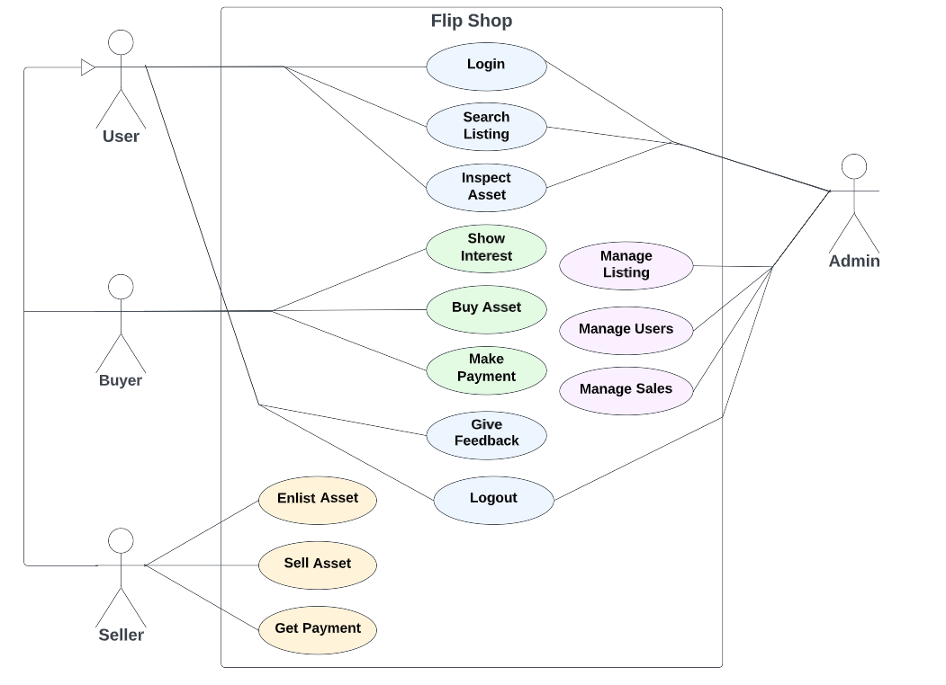

**Login to the system:**

The new use should be able to register to the system. Registered user should be able to login to the system and manage their profile.

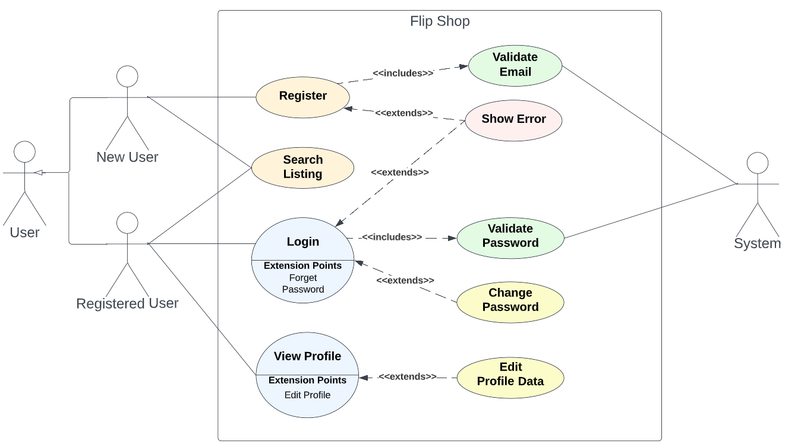

**Enlist Asset:**

The system shall take the asset information from the seller, make API calls to extract the analytics, predict the price based of the asset data and enlist it for sale

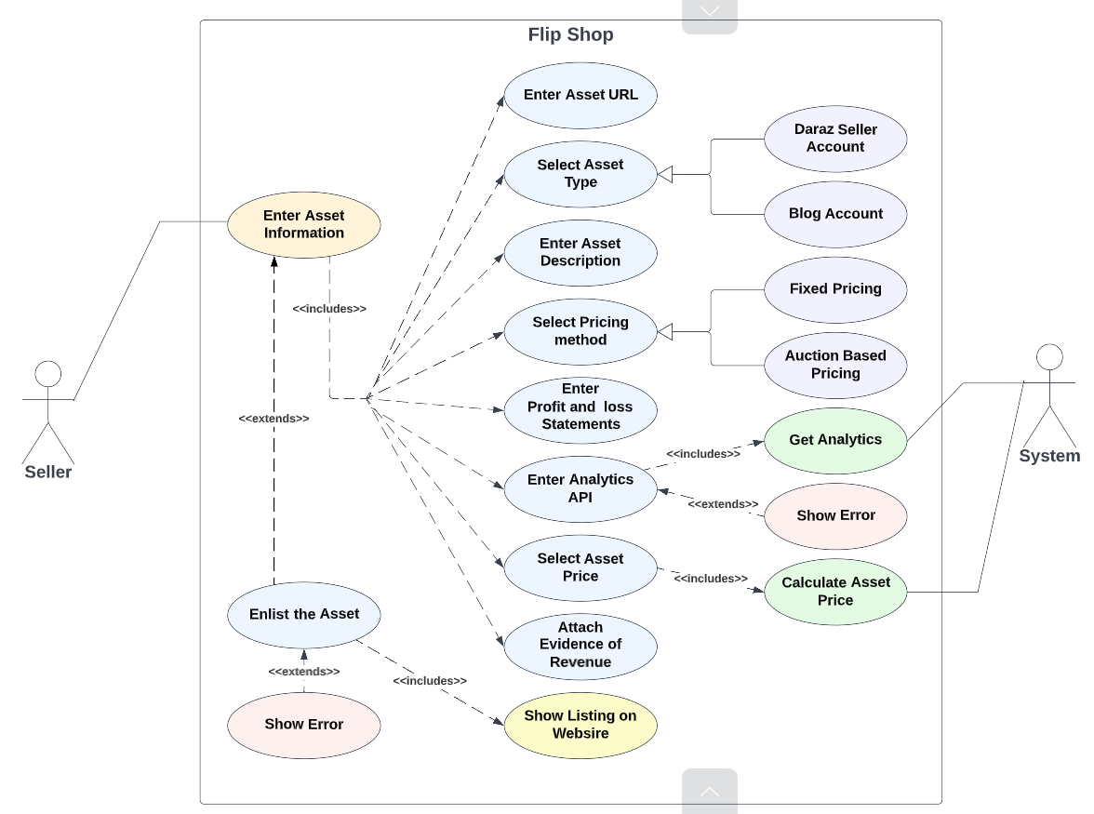

**Sell the asset:**

The seller should be able to enlist the asset, get potential buyers, sell the asset and get payment. The Flip Shop will provide escrow model for the payment transfer between the parties. After successful transaction, the seller should be able to give feedback.

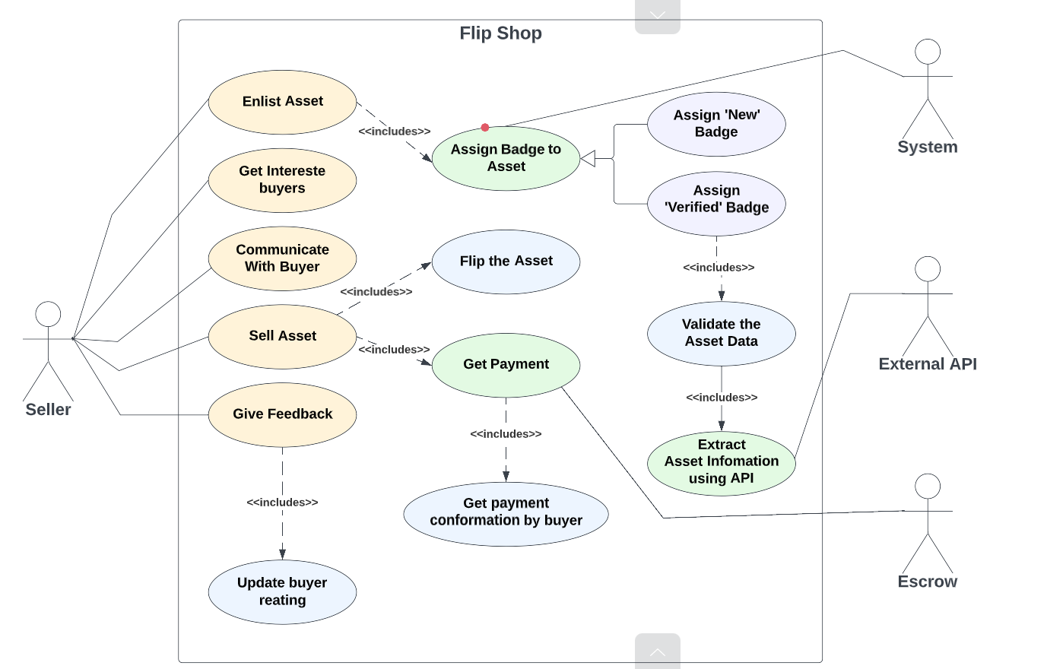

**Buy the asset:**

Buyer should be able to search, inspect and buy asset. After successful transaction, the buyer should be able to give feedback to the seller.

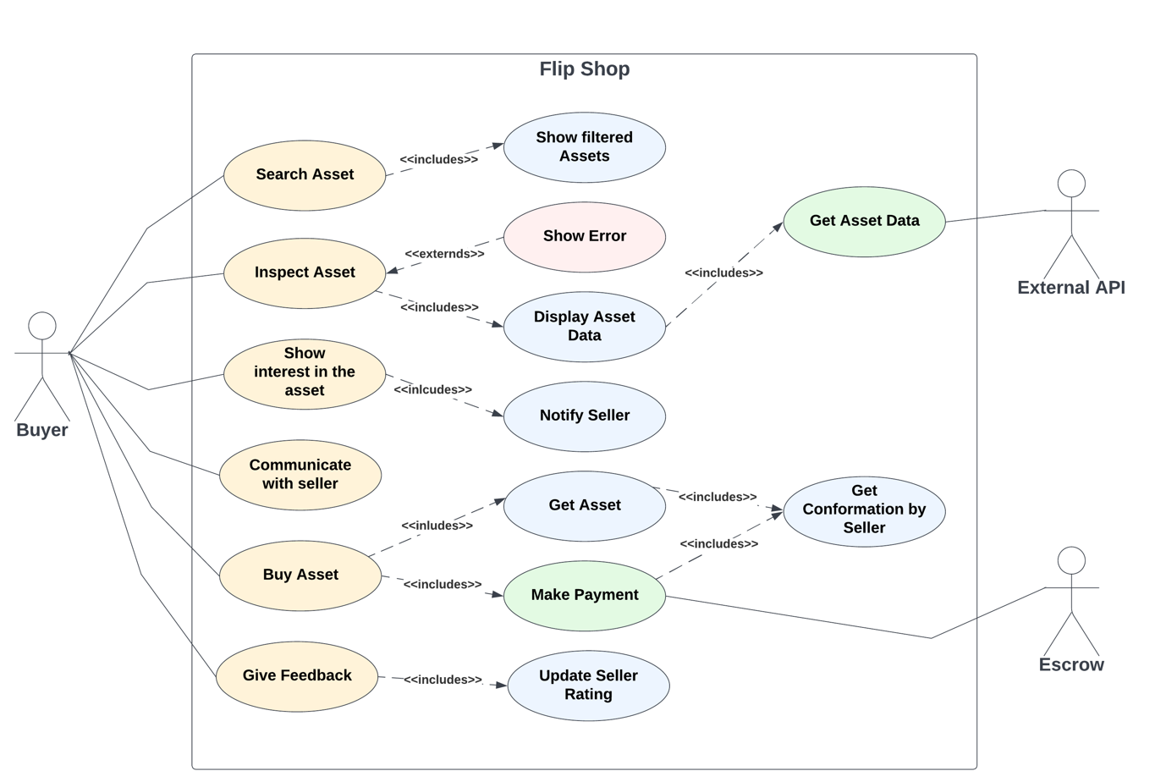

**Appendix C: To Be Determined List**

1. More sections and content of other pages of the website.
2. One or two other analytical tools to be used in addition to Google Analytics and Daraz API and our custom-built model.
3. Business Rules.